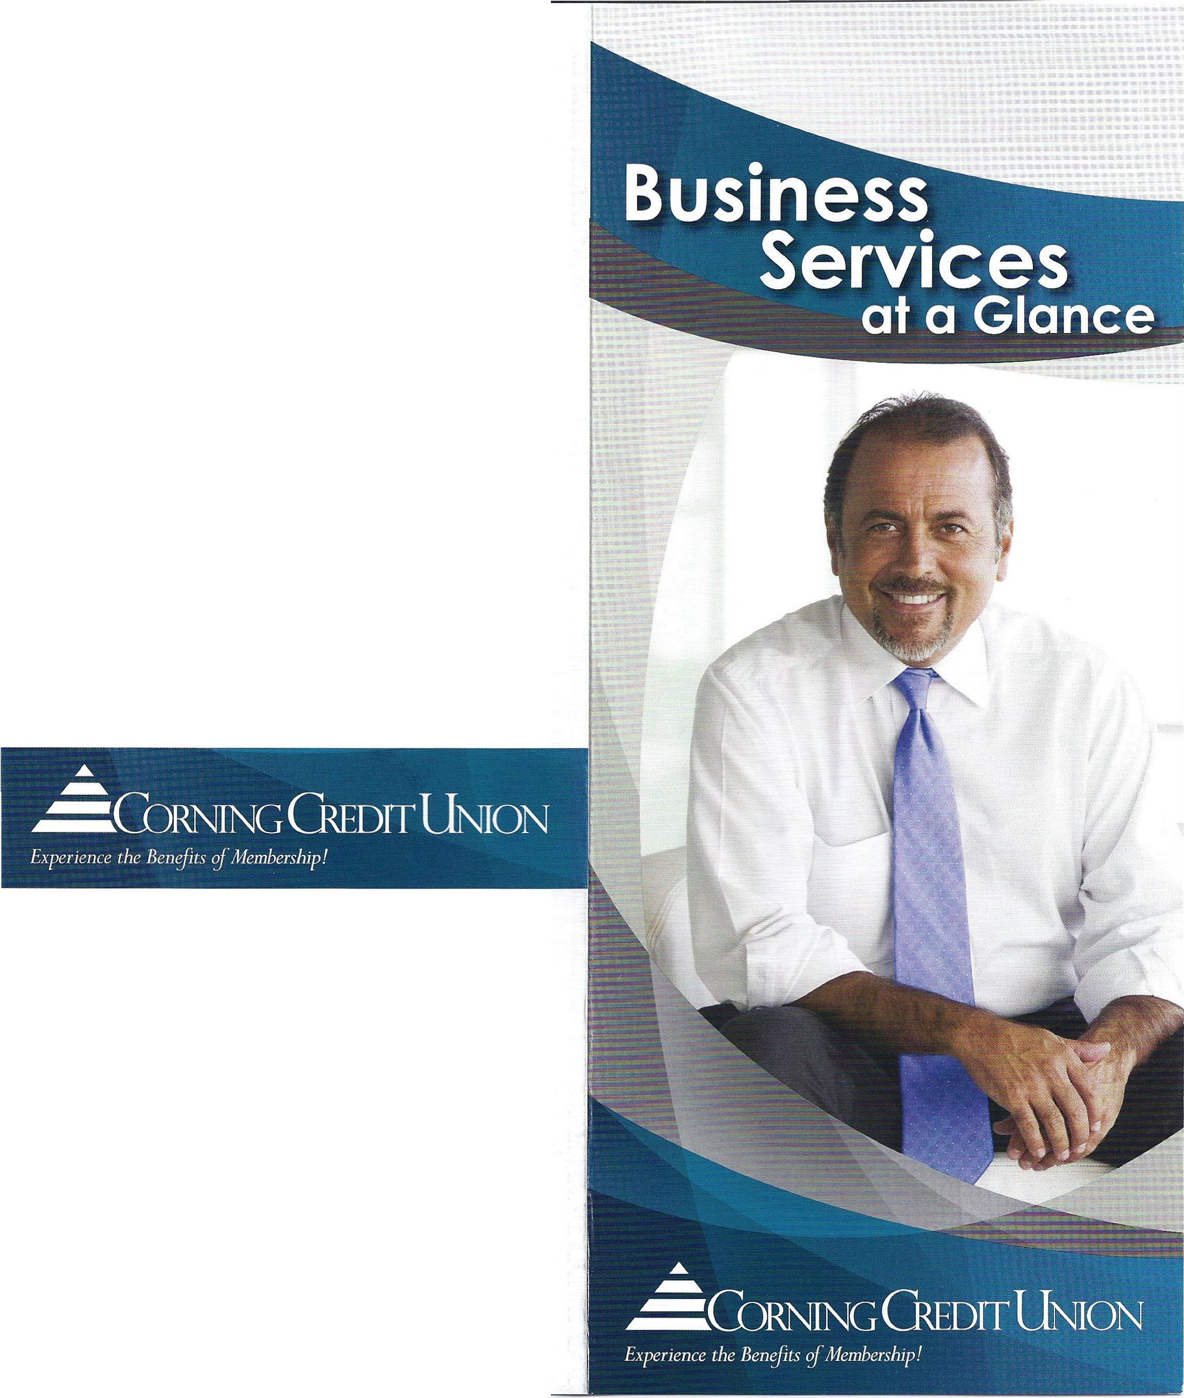Become a Business Partner!
When you become a Business Partner, you provide your employees with an exceptional benefit-they are
eligible to become Corning Credit Union members, too. As a business owner, you' ll also gain access to additional benefits and support from our team of business specialists. Ask how you can become a
CCU Business Partner FREE of charge.

Business Resources
Retirement Planning - CCU Wealth Strategies is available to help you and your employees meet retirement needs with a personalized plan created just for your unique business. Leveraging our association
with Raymond James Financial Services**, CCU Wealt h Strategies combines a broad range of investment products with a great team of people to bring you
the best service. www.corningcu .org/ business / plan-and -invest/ ccu-wealth -strategies

One Credit Union Plaza, Corning, NY 14830- 1050
www .corningcu.org
607-962-3144 • 800-677-8506
Email: mailus@corningf cu.org

Federally insured by NCUA. Membership eligibility required. 'Di•:idends are paid on any day when the balance in the account at the end of the day is $4,000 or more. 2 Corning Credit Union does not charge a fee for using Mobile Check Deposit; however. charges from your wireless carrier may apply. Members must satisfy certain criteria to qualify. Deposit limits and other restrictions may apply.
**Securities and investment advisory services offered exclusively through Raymond James Financial Services, Inc. Member NASD/SIPC. The products offered through Raymond James Financial Services. Inc. are not NCUA insured, not guaranteed by the NCUA or Corning Credit Union, subject to risk and may lose value.

500 EASTWOOD 3/ 14

Business Deposit Accounts
Business Checking 1 is for businesses that have low to moderate transaction volumes . There are no monthly maintenance fees, no minimum balance requirements, and it pays a competitive dividend.

Commercial Checking is for larger businesses that maintain a higher account balance and have high monthly transaction volumes. This account allows you to offset monthly account fees with an earnings credit based on the monthly average account balance.

Business Share Certificates are available in terms ranging from 3 to 60 months, including Jumbo Certificates. Competitive rates, a low minimum balance requirement, and automatic renewal at maturity make this an excellent choice for idle cash.

Money Market Accounts give your business the
advantage of earning a higher monthly dividend on higher maintained balances with the convenience of easy fund access .
Business Savings allows your business to earn a competitive dividend rate on funds, with a low minimum balance of only $5.00.

Automated and Online Services
Online Banking offers FREE, secure, and easy-access online services such as eBranch, eStatements , and Bill Pay right from your computer.

Mobile Banking gives you on-the-go account access options including our mobile eBranch website, mobile apps, Mobile Check Deposit2 (through your mobile phone, tablet , or desktop scanner) , and more.

Premium Business Bill Pay lets you safely and easily pay bills for your business anytime, anywhere. Avoid trips to the post office, writing checks, or paying for stamps.
Available 24/7 .

Business Loans
We offer several options to meet your borrowing needs, plus the convenience, world-class service , and competitive rates you expect and deserve.

Line of Credit options can be used to finance short-term fluctuations in working capital requirements. Businesses may take an advance up to their credit limit, repay, and borrow again, as needed.

Installment (Term) Loans are designed to fit your business needs. Term loans are appropriate for long­ term capital purchases such as machinery, equipment, and vehicles.

Commercial Mortgage Loans can be used to purchase, refinance, or refurbish owner-occupied property. The Credit Union also offers financing for non-owner occupied and investment property.

Small Business Administration (SBA) Loans are for the purpose of starting a new business, buying an existing business, or obtaining a loan that is outside normal lending guidelines.

Business Visa® credit cards help you take care of your business by offering immediate access to available credit and optional enrollment in the Business Cash Rewards Program.

Business Support Services
Merchant Services offer businesses a way to make accepting and processing credit cards, debit cards, and gift cards easy and convenient for all types of industries.

Payroll Services can save you time, help you operate your business more effectively, and allow you to focus on growing your business.

"' % - " w + l - - - "' - - i4 Mt'IM
t
607-962-3144 • 800-677-8506 : : - , ; .co; igcu.or;;:;:
I -

CCU Business Loans
We offer several options to meet your borrowing needs, complete with the convenience, world-class service, and competitive rates you expect and deserve. At a minimum, the documents needed to apply for a loan include:

O Business loan application
O Personal financial statement for all owners/ guarantors
03 years of Federal Income Tax Returns for all owners/ guarantors
03 years of Federal Income Tax Returns for the business
O Additional information, as requested

Business Visa®:
O Business Visa Application
O Additional information, as requested

We know your time is valuable.
Please schedule an appointment so we can better serve you. Give us a call at
800-677-8506, option 5. For more information, visit www.corningcu.org / business .

One Credit Union Plaza, Corning, NY 14830-1050
www.corningcu.org
607-962-3 144 • 800-677-8506
Email: mailus@corningfcu.org

Federally Insured by NCUA. Membership eligibility restrictions may apply for certain businesses
and locations. 10perating Agreement is recommended, but not required in North Carolina.

1000 HHDS 12/13

Ir How to Get Sfrted

Business Accounts
CCU Business Services knows your time is valuable. Please use the following checklist to determine which documents you need to bring with you to open your business account.

Sole Proprietorship:
D OBA (Doing Business As) Certificate (not required in North Carolina)
May also be called Fictitious Name, Business, or Assumed Name Certificate.

Limited Liability Company or Professional LLC:
D Articles of Organization (with amendments)
DOperating Agreement (not required in North Carolina) 1
D Foreign (or out of state) Corporations : Authorization to Do Business Within State (if applicable)

Unincorporated Association:
DBylaws

Limited Partnership/Limited Liability Partnership:
D Certificate of Limited Partnership
DPartnership Agreement (may be verbal in New York)

Corporation:
D Articles or Certificate of Incorporation
D Foreign (or out of state) Corporations: Authorization to Do Business Within State (if applicable)

General Partnership:
D DBA (Doing Business As) Certificate (not required in North Carolina)
May also be called Fictitious Name, Business, or Assumed Name Certificate .
D Partnership Agreement (may be verbal in New York)

Please note that business types other than a Single Member LLC or a Sole Proprietorship require an Employer Identification Number to open an account. Single Member LLCs and Sole Proprietorships may use the owner's social security number.

See reverse for more information and disclosures

